

Comma Productions Professional Development Program

Level 5: Open For Business

Lesson Plan and Background Notes

Lesson Title: | Open For Business
Subject Area: | Technology
Grade Level: | 6-12, College
Lesson Summary: | At the end of this unit, the student will be able to:  Technology: Intermediate Excel: Format font styles (size, color, and styles), Apply number formats (currency, percent), Format borders and shading, Use AutoSum, Insert and delete rows or columns, Hide and unhide rows and columns, Set up headers and footers, Use references (relative), Use Functions: Average and IF  Mathematics: Analyze and chart the start up costs for a small business including calculating a price sheet, adding the salaries and cost of business (rent, heat, phone)
Learning Objectives: | - Students will define labels, fill down data, sort, auto fit and hide columns in Microsoft Excel  - Students will create a price sheet  - Students will create a sample check book  - Using a sample spreadsheet, students will add up all costs
Benchmark and Standard: | N.ME.06.06  N.MR.06.08, 9, 10  N.FL.06.14  A.FO.06.03  A.RP.06.08  Grade Level Expectations:  Basic operations and concepts 1, 2, 3, 5, 6, 9, 10, 13  Technology research tools 1, 2, 3  Technology problem solving tools 1, 2  NETS-S I A, B  NETS-S II B  NETS-S III B  NETS-T I A, B  NETS-T II A, B, C, D
Approximate Time: | 7 hours
Prerequisite Skills: | - Students should know basic menu functions: New, Open, Save, Undo Copy, Paste  - Students should have basic file management skills

Materials and Resources Required
Technology: | Computer(s)  Microsoft Windows 2000, XP, Microsoft Word 2000, XP or 2003, Microsoft Excel 2000, XP or 2003, Internet Explorer  Computer hardware  - Demonstration PC with two hard drives  - Windows NT, 2000 or XP are required to demonstrate security and user administration
Printed Materials: | Chapter 5 of the Guide  Exercise sheet
Preparation: | Prior to class:  - Prepare floppy disks with the sample Excel files  - Confirm the security settings for the network
Procedures: | It All Adds Up (1 hour)  - Create a price sheet that includes wholesale cost, markup (percentage) and retail price  - Create an expense sheet  - Consolidate the costs and prices on one sheet  - Estimate how many products must be sold for their expected salaries  - Format, AutoFit and Hide the columns  A Question of Balance (1 hour)  - Students will create a sample checkbook  - Equations will be calculated manually  - Students will learn about working with series  Practice: How Much Did That Cost? (1 hour)  Using a sample checkbook, students will practice creating summary costs for each category: utilities, telephone, and postage.  Take Control: Roll Out The Red Carpet (.5 hour)  Use the video display to promote your business  - Create a business logo in Microsoft Paint  - Use the Control Panel to change the desktop display  TechTalk: If You Have A Lot Of Drive You’ll Go Far (.5 hour)  Hardware demonstration: installing a hard drive  - Review the architecture of a hard drive  - Calculate how much room is available on the hard drive  - How much room is required for the Windows operating system  The Administrator: Getting Down To Business (1 hour)  Business operating system versus home operating systems.  - User Groups: Users, not Administrators  - The purpose of passwords  Setting up passwords
The Sandbox: Take It Into Overdrive (.5 hour)
Hard drive defragmenting

Challenge Series (1 hour)
Create a spreadsheet listing the different user groups and their permissions
Note to instructor: | The hardware focus is on understanding how much storage is available, and what steps are required for good maintenance.

Background Notes
In the previous lessons, the focus was on the “personal” computer. With Level 5, the emphasis is on building and supporting a business.

Review the Nomenclature of the Microsoft Excel Application
Is there a Blue Title Bar that Says Microsoft Excel-Book 1?
Is there a Standard Menu bar that says, “File, Edit, View, Insert, Format, Tools….Help?
Is there a Standard Tool Bar that says, “New, Open, Save…Cut, Copy, Paste?”
Finally, is there a Formatting Tool Bar that has, “Normal, Times New Roman, 10pt?”

This method of orientation reinforces the similarity between products. Keep it simple and focus on five or less functions per training period. Please do not use technical jargon!

Take A Byte: It All Adds Up
Create the labels for the Excel list
- Add the Labels
  - First Name, Last Name, Department, Salary
- Select Row 1 and format the labels big, bold, and centered

Add the data
- Type in at least five records
- Confirm that using Tab on the keyboard takes the student across the row
- Watch: when the students get to the end of the row, using the Enter key on the keyboard returns them to cell B1.

Formatting the Cells
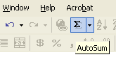
Select column B and use the Currency tool
- Note: the numbers are aligned with two decimal places
- Use the toolbar to increase and decrease the decimal places
- Select column C and use the Percent tool

Creating Equations
Use the AutoSum tool to add up the total cost

A Question of Balance
Set up the labels
- Format the Cells
  - Select Column B and format the cells for date
  - Select Column D, E, and F and format the cells for currency
- Add the sample data
Calculating the Balance
Create the following equation in cell F3: =F2-D3+E3.
- In real words, this equation says, “Take the previous balance, subtract whatever checks that were entered in cell D3 and add whatever deposits were entered in cell E3
- Proof your equation by double clicking on cell F3

Working with Equations
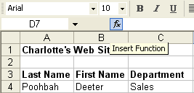
Microsoft Excel has a Formula Tool to assist you in creating Functions and Arguments.

Set up a simple Employee spreadsheet
- Set up labels for Last Name, First Name, Department, and Salary
- Select the Column for Salary and Format the cells as currency
Calculate the Average Salary
- Select cell D7 to start
- Click on the Function tool
  - Select AVERAGE from the list of functions
  - Proof the equation that the Function Wizard developed: =AVERAGE(D4:D6)
Create a Conditional Equation
- Select cell E4 to start
- Click on the Function tool
  - Select IF from the list of functions
  - Create the logical statement: D4>D7
  - Enter the values for True and False
  - Proof the equation: =IF(D4>D7, “Above”, “Below”)

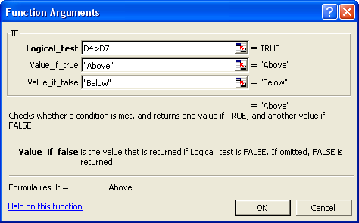

Take Control: Roll Out The Red Carpet

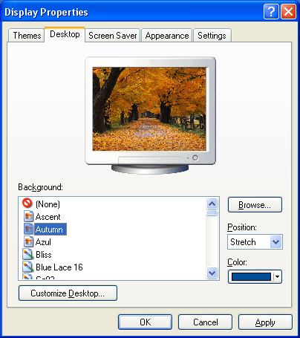
Putting Your Logo on the Desktop
Go to the Control Panel Start -> Settings -> Control Panel
Double Click the Display applet
Choose the Background page of the Display properties
Play with the stock options
  - Patterns
  - Centered or tiled

Now, create a corporate image
Create a corporate logo in Paint
Save the file as a Bitmap (*.bmp)
In the Display properties, Browse for the corporate logo

Challenge Series
Create a new company or product logo with a digital camera
Enhance the photo with text in Microsoft Paint
Save the file as a Bitmap (*.bmp)
In the Display properties, Browse for the corporate logo

TechTalk: If You Have A Lot Of Internal Drive, You’ll Probably Go Far

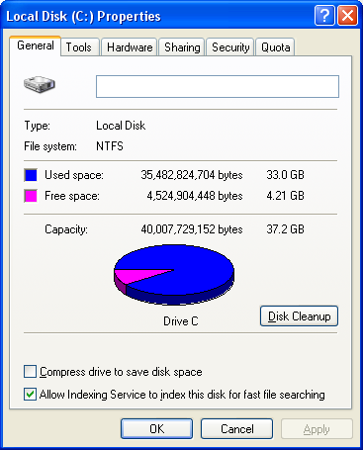
Exploring the hard drive
Right mouse click My Computer and select Explore
Examine the Explorer Window
  - Is there a Blue Title Bar that says, “Exploring C:\” or “Local Disk C:\” ?
  - Is there a Menu Bar that says File, Edit, View….Help?
  - Is there a Standard Tool Bar?
  - Is there a left pane for containers—drives, folders, and network places?
  - Is there a right-hand viewing pane to see what’s in the containers?
On the left hand side select the C:\ hard drive
Right mouse click the C:\ drive a select Properties
Review the free/used pie chart

Document the system
Make a screen capture of the pie/chart by pressing Ctrl+ Print Scrn on the keyboard.
Paste the screen capture in a new Word document.
Finish the report by adding
  - Computer Name or Serial Number
  - Physical Location
  - Insert the Date/Time
  - Prepared by…..
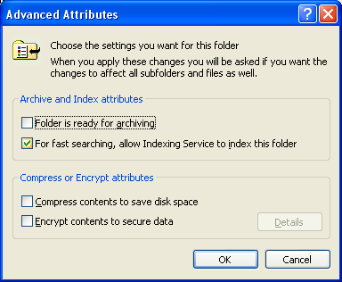
Options If The Computer Is Out of Space
File Compression
Right mouse click My Computer and select Explore
Select the Student folder on the local hard drive
Right mouse click and select Properties
Select Compress
Compare the amount of space gained by compression

Add another hard drive
Decide which drive will be the Master and which one will be the slave
Review the jumper settings provided by the hard drive manufacturer
Review the procedure for installing the hardware drivers
Confirm, that the hard drive, just like a floppy, has to be formatted before it can be used.

The Administrator: Setting the Limits

A discussion of file and folder sharing
Right mouse click My Computer and select Explore
Select the Student folder on the local hard drive
Right mouse click and select Properties
Review that Windows 95, Windows 98 and Windows ME sharing is Everyone or No One—a false sense of security
Compare Windows NT/2000/XP where security is based on Users and User Groups
Demonstrate Adding a new user with the Windows 2000 Computer Management

Students should document the Permissions on their student folder using the same techniques to document the properties of the hard drive.

