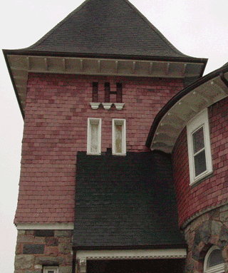

Charlotte’s Website
555 Main Street
Brighton, MI 48116
Is Pleased to Invite
Deeter Poohbah
To Our Open House
Nov 7th 2008
From 1:00 PM – 5:00 PM

