Rain Washes Out Hamburg

Locally heavy rains soak southeast Michigan with more downpours on the way
October 25, 2007, 2:00 P.M. EDT
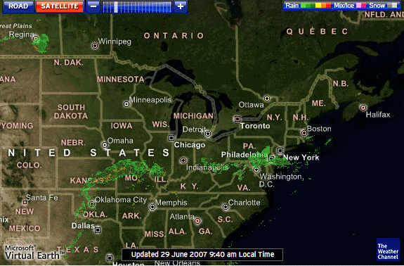
Cloudbursts over southeastern Michigan early today dumped 2 to 3 inches of rain around the Hamburg area with isolated totals of 4 to 6 inches. Additional heavy rainfall is likely through tonight and a Flash Flood Watch may be required. The copious rainfall is being caused by a stream of moisture feeding inland from the Gulf of Mexico. This influx of juicy air likely will persist into Thursday as high pressure to the east has anchored itself and will continue to force the soggy air northward through eastern Michigan and western Ohio.

By tomorrow the stream of moisture will reach all the way to the Canadian border as a deepening storm moves north-northeastward out of Colorado.

Today, the upper air disturbance that will enhance the Colorado storm tomorrow is bringing gusty winds, cooler air, and scattered showers and thunderstorms to the Intermountain West. Snow showers are coating the higher elevations of the area. The Northeast also is breezy and cooler, but without the aggravation of precipitation. Much of the country east of the Mississippi remains unseasonably warm and dry.

Meanwhile, the Pacific Northwest is bracing for another powerful Pacific storm. Atmospheric pressures in the Gulf of Alaska are nose-diving as the storm strengthens and drops southeastward. High Wind Watches for tonight and tomorrow have been issued for the Washington coast and most of the Oregon coast. Soaking rains will move inland tonight and tomorrow, with snow in the higher reaches of the Cascades. The precipitation will plunge all the way to Northern California tomorrow.

