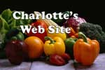
Charlotte’s Website
The Best in Farm Fresh Food Delivered to Your Door!
Grand Opening
Sale!
July 4, 2008

